**PYTHON SCRIPT**

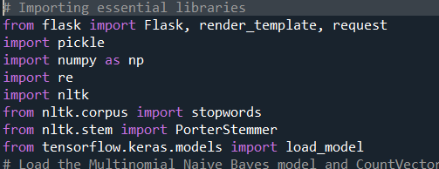

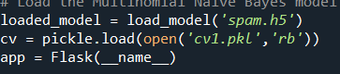

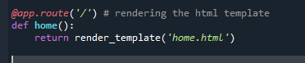

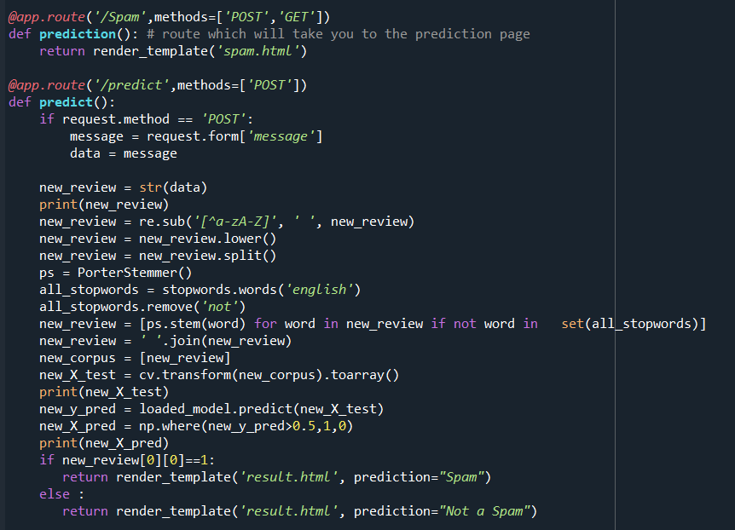

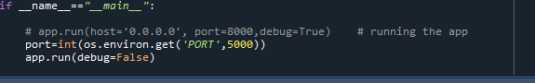

from sklearn.metrices import confusion_matrix,accuracy_score

cm=confusion_matrix(y_test,y_pr)

score=accuracy_score(y_test,y_pr)

print(cm)

print('Accuracy Score Is:-',score*100)

model.save('spam.h5')

from flask import Flask,render_template,request

import pickle

import numpy as np

import re

import nltk

from nltk.corpus import stopwords

from nltk.stem import PorterStember

from tensorflow.keras.models import load model

loaded_model=load_model('spam.h5')

cv=pickle.load(open('cv1.pkl','rb'))

app=Flask(_name_)

@app.route('/')#rendering the html template

def home()

return render_template('home.html')

@app.route('/spam',methods=['POST','GET'])

def prediction():#route which will take you to the prediction page

return render_template('spam.html')

@app.route('/predict',methods=['POST'])

def predict():

if request.method=='POST':

message=request.form['message']

data=message

new_review=str(data)

print(new_review)

new_review=re.sub('[a^-zA-Z]','',new_review)

new_review=new_review.lower()

new_review=new_review.split()

ps=PoterStemmer()

all_stopwords=stopwpords.words('english')

all_stopwords.remove('not')

new_review=[ps.stem(word) for word in new_review if not word in set(all_stopwords)]

new_review-''.join(new_review)

new_corpus[new_review]

new_x_test=cv.transform(new_corpus.toarray()

print(new_x_test)

new_y_pred=loaded_model.predict(new_x_test)

new_x_pred=np.where(new_y_pred>0.5,1,0)

print(new_x_pred)

if new_review[0][0]==1:

return render_template('result.html',prediction="spam")

else:

return render_template('result.html',prediction="not a spam")

if_name_=="_main_":

#app.run(host='0.0.0.0',port=8000,debug=True) #running the app

port=int(os.environ.get('PORT',5000))

app.run(debug=False)

base)D:\TheSmartBridge\projects\2.DrugClassification\Drug

From flask import flask,render_template,request

Import pickle

Import numpy as np

Import re

Import nltk

From nltk.corpus import stopwords

From tensorflow.keras.models import load_model

Loaded_model=load_model('spam.h5')

CV=pickle.load(open('cv1.pkl','rb'))

App=flask(name)

@app.route('/')

Def home():

Return render_template('home.html')

@app.router('/spam'methods=['post','get'])

Def prediction():

Return render_template('spam.html')

@app.route('/predict',methods=['post'])

Def predict():

If request.method=='post':

Message=request.form['message']

Data=message

New_review=str(data)

Print(new_review)

New_review=re.sub('[^a-za-z]','',new_review)

New_review=new_review.lower()

New_review=new_review.split()

Ps=porterStemmer()

all_stopwords=stopword.words('english')

All_stopwords.remove('not')

New_review=[ps.stem(word)for word in new_review if not word in set(all_stopwords)]

New_review=''.join(new_review)

New_corpus=[new_review]

New_x_test=CV.transform(new_corpus).toarray()

Print(new_x_test)

New_y_pred=loaded_model.predict(new_x_test)

New_x_pred=np.where(new_y_pred>0.5,1,0)

Print(new_x_pred)

If new_review[0][0]==1:

Return render_template('result.html',prediction="spam")

Else:

Return render_template('result.html',prediction="not a spam")

If_name_=="main_":

Port=int(os.environ.get('port',5000))

App.run(debug=false